Jimi Porter

CIS 310-01

Due 09/01/2019

**Chapter 2 Homework**

**1.** The business rules that govern the relationship between AGENT and CUSTOMER is that there could be one AGENT to many CUSTOMER(s) and there could be that each CUSTOMER can only be assisted by one AGENT.

**2. Crow’s Foot ERD**

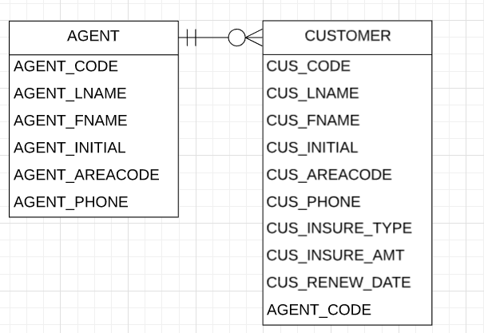

**3. Object Representation UML Diagram**

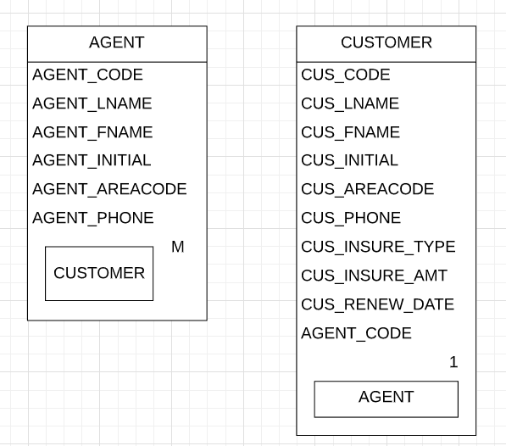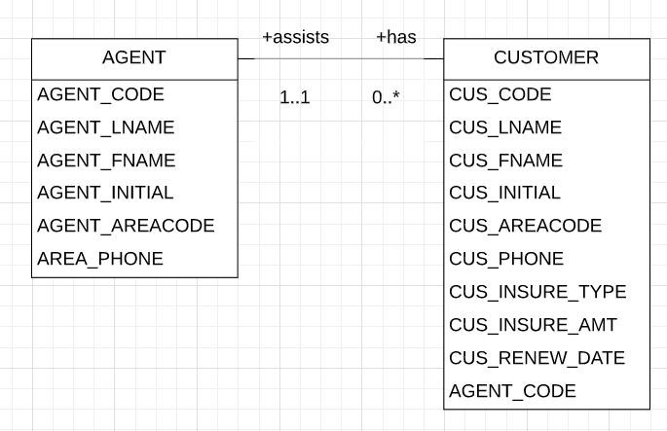

**4.** One region has many stores and many stores can be in one region. This is a one to many relationship. One store has many employees, and many employees work in one store. This is also a one to many relationship. Many employees have one similar job, and one similar job applies to many employees. This is a one to many relationship.

**6.** One course has many classes, many classes can embody a course. This is a one to many to relationship. One class has many enrolled in it, and many can enroll in one class. This is a one to many relationship. Many enrollments are made by one student, and one student can be enrolled many times. This is a one to many relationship.

**7. Crow’s Foot ERD**

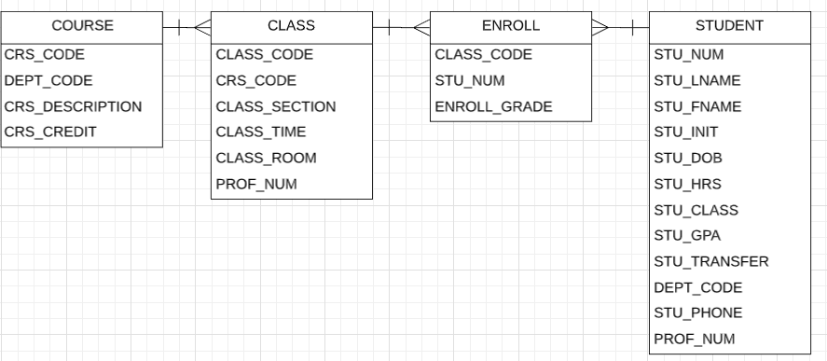

**8. UML Diagram**

